**Sam Lazrak**

**CS 330 Computer Organization/Assembly Language**

**Homework Assignment 4**

**3/2/18**

Consider these review concepts from Chapter 5:

5.3, 5.4 What are the differences between DRAM and SRAM in terms of application, and characteristics such as speed, size and cost?

* SRAM is used for cache memory (both on and off chip), and DRAM is used for main memory. SRAMs generally have faster access times than DRAMs. DRAMS are less expensive and smaller than SRAMs.

5.6, 5.7, other: Trace the similarities and differences between ROM, PROM, EPROM, EEPROM and Flash memory, including uses of each.

* **ROM** isa read-only memory containing a permanent pattern of data that cannot be changed. A ROM is nonvolatile; that is, no power source is required to maintain the bit values in memory. While it is possible to read a ROM, it is not possible to write new data into it. An important application of ROMs is microprogramming.
* **PROM** is the programmable ROM which is a less expensive alternative to ROM where only a small number of ROMs with a particular memory content is needed. Like the ROM, the PROM is nonvolatile and may be written into only once. For the PROM, the writing process is performed electrically and may be performed by a supplier or customer at a time later than the original chip fabrication. Special equipment is required for the writing or “programming” process. PROMs provide flexibility and convenience.
* **EPROM** is read and written electrically; before a write operation, all the storage cells must be erased to the same initial state by exposure of the packaged chip to ultraviolet radiation. Erasure is performed by shining an intense ultraviolet light through a window that is designed into the memory chip.
* **EEPROM** is a read mostly memory that can be written into at any time without erasing prior contents; only the byte or bytes addressed are updated.
* **Flash memory** is intermediate between EPROM and EEPROM in both cost and functionality. Like EEPROM, flash memory uses an electrical erasing technology. An entire flash memory can be erased in one or a few seconds, which is much faster than EPROM. In addition, it is possible to erase just blocks of memory rather than an entire chip. However, flash memory does not provide byte-level erasure. Like EPROM, flash memory uses only one transistor per bit, and so achieves the high density (compared with EEPROM) of EPROM.

Consider these review concepts from Chapter 6:

1. Review RAM, Flash Memory, Magnetic and Optical storage technologies concerning their placement in the usage hierarchy of contemporary computer systems. Include size, speed and cost considerations at each level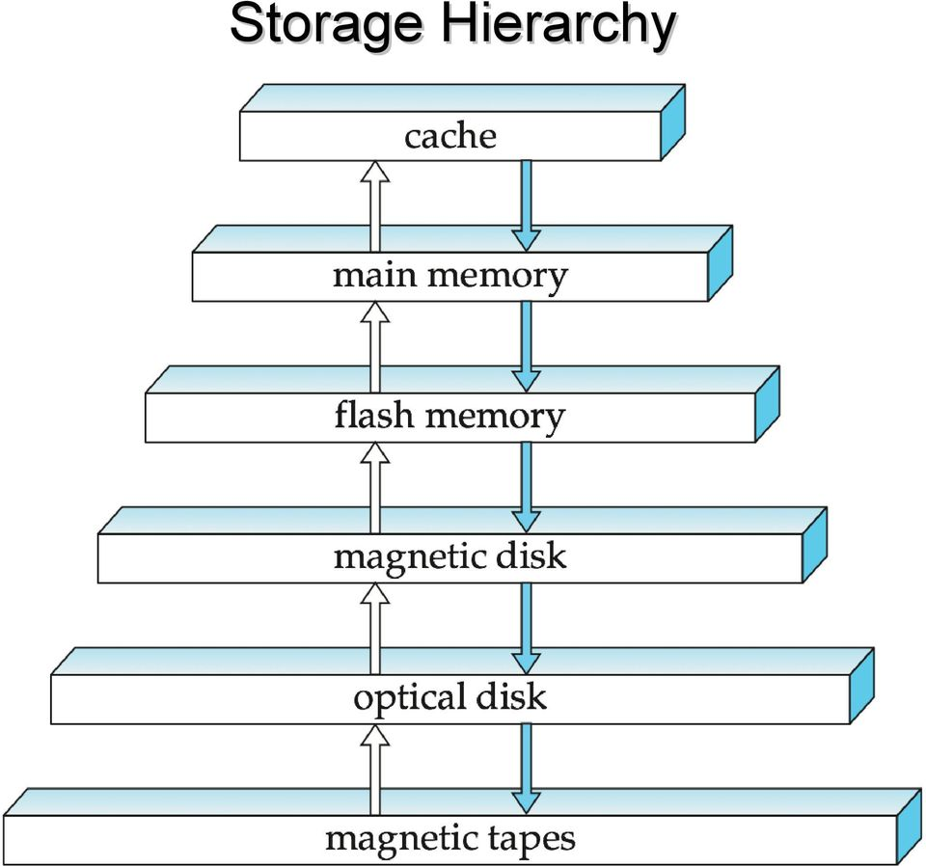

1. Explain RAID in terms of goals, redundancy and overhead costs.

* **Goals:** The RAID strategy employs multiple disk drives and distributes data in such a way as to enable simultaneous access to data from multiple drives, thereby improving I/O performance and allowing easier incremental increases in capacity. The unique contribution of the RAID proposal is to address effectively the need for redundancy. Although allowing multiple heads and actuators to operate simultaneously achieves higher I/O and transfer rates, the use of multiple devices increases the probability of failure. To compensate for this decreased reliability, RAID makes use of stored parity information that enables the recovery of data lost due to a disk failure.

Increasing speed

and cost per bit

Increasing size

* **Redundancy:** Redundant disk capacity is used to store parity information, which guarantees data recoverability in case of a disk failure. For RAID level 1, redundancy is achieved by having two identical copies of all data. For higher levels, redundancy is achieved by the use of error-correcting codes.
* **Overhead costs:** RAID 1 has the highest disk overhead of all RAID types (100%) which is inefficient. For RAID 6, controller overhead to compute parity addresses is extremely high.

1. Explain optical disc nomenclature including CD, DVD, and Blu-ray discs including which variants are writable, write-once, and rewritable, and approximate size comparisons.

* **CD (Compact Disk):** A non-erasable disk that stores digitized audio information. The standard system uses 12-cm disks and can record more than 60 minutes of uninterrupted playing time.
* **CD-ROM (Compact Disk Read-Only Memory):** A non-erasable disk used for storing computer data. The standard system uses 12-cm disks and can hold more than 650 Mbytes.
* **CD-R (CD Recordable):** Similar to a CD-ROM. The user can write to the disk only once.
* **CD-RW (CD Rewritable):** Similar to a CD-ROM. The user can erase and rewrite to the disk multiple times.
* **DVD (Digital Versatile Disk):** A technology for producing digitized, compressed representation of video information, as well as large volumes of other digital data. Both 8 and 12 cm diameters are used, with a double-sided capacity of up to 17 Gigabytes. The basic DVD is read-only (DVD-ROM).
* **DVD-R (DVD Recordable):** Similar to a DVD-ROM. The user can write to the disk only once. Only one-sided disks can be used.
* **DVD-RW (DVD Rewritable):** Similar to a DVD-ROM. The user can erase and rewrite to the disk multiple times. Only one-sided disks can be used.
* **Blu-ray (DVD High-definition video disk):** Provides considerably greater data storage density than DVD, using a 405-nm (blue-violet) laser. A single layer on a single side can store 25 Gigabytes.